**Lab 12**

**Interfacing ADC with 8051 Microcontroller**



**Spring-22**

**Microprocessor Based System Design Lab**

Submitted by: **Ashfaq Ahmad**

Registration No: **19PWCSE1795**

Class Section: **B**

“On my honor, as a student of the University of Engineering and Technology, I have neither given nor received unauthorized assistance on this academic work.”

Student Signature: ______________

Submitted to:

**Dr. Abeer Irfan**

August 3, 2022

Department of Computer Systems Engineering

University of Engineering and Technology, Peshawar

**Code:**

|  |
| --- |
| #include <reg51.h>  sbitRD_n = P3^0; //P3.0 is connected to the RD pin of ADC sbitWR_n = P3^1; //P3.1 is connected to the WR pin of ADC sbit INTR = P3^2; //P3.2 is connected to the INTR pin ofADC  void Ext0(void); //Function that is called after the ADC is done with conversion  void main(void)  {  P2 = 0xFF; //Set P2 as an input Port  P1 = 0x00; //Set P1 as an output Port INTR = 1; //Set P3.2 as an input pin  while (1)  {  RD_n = 1; //Set the RD pin to High  WR_n = 0;//WR = Low WR_n = 1;//Low-->High  while(INTR==1); //Wait for the ADC to Convert the given  Ext0(); //Call the Ext0 function  }  }  void Ext0()  {  RD_n = 0; //Set the RD pin of ADC from HIGH to LOW  P1 = P2; //Send the value at P2 to P1  } |

**Output**

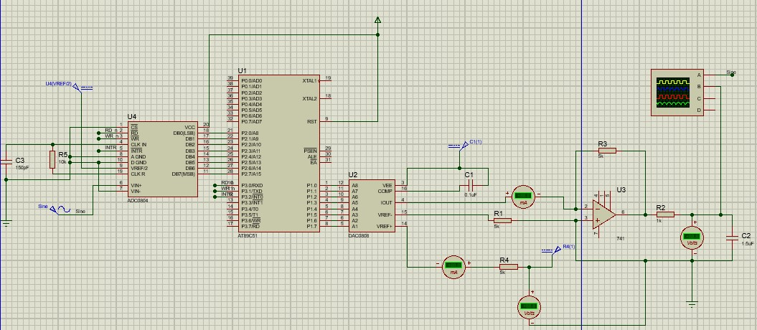

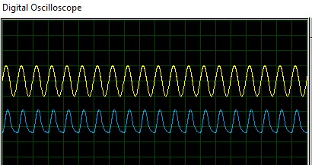

**Ended**